(2016 ver.) GERARD'S STOLLEN Makes 4 loaves.
Takes about 4-5 hours start to finish.
4 ½ cups Flour If making more than 4, start 2nd batch
1 T. Yeast while first one rises.
1/3 cup Sugar Mix dry ingredients at mixer speed #2. Set aside.
2 tsp. Salt
````````````````````````````````` ```````````````````````````````````````````````````````````
1 ½ cups Milk Warm the milk 70 seconds in micro.
1 Egg, beaten In separate bowl, mix egg and milk.
````````````````````````````````` ```````````````````````````````````````````````````````````
¼ cup & 2 T. Shortening To measure, put 16 oz. water in 4 cup measuring cup, then add shortening
until water rises to 22 oz. mark. Pour off water.
After measuring, melt shortening 55 seconds in micro.
Add to milk mixture.
```````````````````````````````````````````````````````````
Drizzle mixture into flour while mixing on speed #2. Mix 5 minutes.
````````````````````````````````` ```````````````````````````````````````````````````````````
¼ cup (varies) Flour Add extra flour. Do not add too much. Dough should stick to the bowl
a little bit. Mix with dough hook about 8 minutes.
````````````````````````````````` ```````````````````````````````````````````````````````````
Proofing #1 Warm oven slightly, then turn off. Put dough into a large bowl.
Cover with a clean dishtowel. Let rise in a warmed oven with door closed
until dough doubles. (Takes about an hour or so. Keep oven warm)
```````````````````````````````` `````````````````````````````````````````````````````````````````
Punch down dough. Divide into 4 equal balls (or 8 minis).
On floured surface, roll out one ball at a time into a rectangle,
1/4” thick and about 10” x 15” or so.
````````````````````````````````` ```````````````````````````````````````````````````````````
1 stick butter, melt Brush butter long-wise down center third of dough.
Cinnamon Sprinkle cinnamon over butter.
Fruit & nuts Sprinkle fruit and nuts over center section. Not too much.
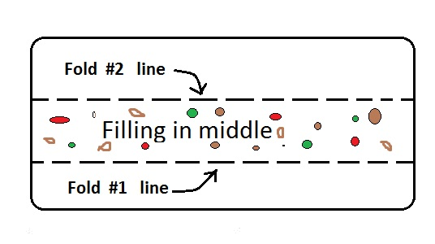
(As desired, Raisins; chopped dates; chopped apricots; candied cherry halves; fruitcake mix; dried or fresh apples, chopped; coarsely chopped walnuts or pecans, etc.)
Sprinkle with additional cinnamon, then dust with flour and sprinkle on water.
```````````````````````````````````````````````````````````
Fold one long edge of dough over the filling in the center. On long edge of
the last third of dough, moisten a strip about 1” wide with water and fold it
up over the center as above, crimping the dough edge to seal.
```````````````````````````````` `````````````````````````````````````````````````````````````````
Proofing # 2 Place parchment paper on two large baking sheets (not air-bake).
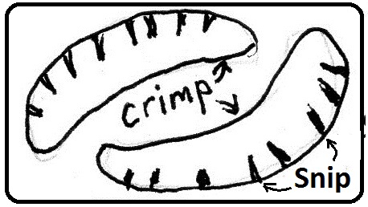
Put 2 stollen on each baking sheet in a crescent shape. Snip dough
along outer curve about an inch or so deep.
(Warm oven as before.) Cover dough with a clean cloth.
Place in oven and allow dough to rise again until doubled.(1-2hrs.)
```````````````````````````````` `````````````````````````````````````````````````````````````````
Preheated oven to 325 degrees.
Brush tops with melted butter.
Bake 25-30 minutes or until light golden brown and bread sounds hollow when tapped with fingernail.
```````````````````````````````````````````````````````````
Remove from baking sheets and let cool completely on wire racks.

